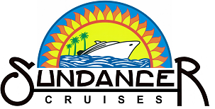

WIN A FREE CRUISE
JUST COMPLETE OUR CONTACT FORM

SPECIALIZING IN DANCE CRUISES
Lots Of Social Dancing & Workshops Plus Hosts

Contact: Cathy & Brent Paxton
303-250-7344 in Colorado ♦ Toll Free: 1-866-409-SAIL
Email: info@SundancerCruises.net
For More info visit: www.SundancerCruises.net

WATCH FOR DETAILS FOR UPCOMING DANCE CRUISES

